Installing new lifters/lash adjusters
Without removing timing belt.

This is a brief description for those who aren’t very mechanically inclined (like me). I have a 1991 VR4, however the process is basically the same for NA’s. As you can see in the 1st picture, the oil holes for the upgraded lifters are much wider than the stock. This is why most of us have that annoying “ticking” sound coming from our engines. The only tools I used was the biggest screwdriver I had, a smaller screwdriver, pair of pliers, and a offset 8mm wrench. Also, it is a good idea to “prime” the lifters by letting them soak in oil for a few minutes. This helps keep air from being trapped in the lifters after they are installed.

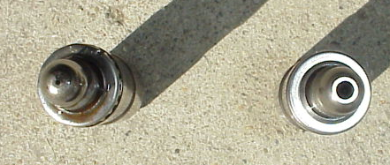

- Raise your car and remove the driver’s side front wheel.

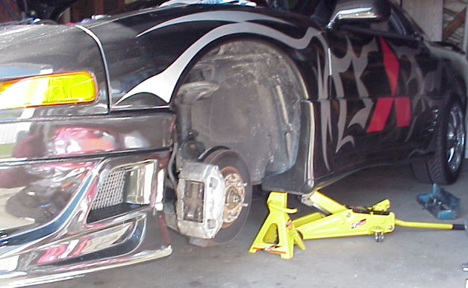

2. Locate the crank pulley. It is behind the front driver’s side tire. You will need to rotate your crank during this process. You can either use a socket to turn the crank, or a ½ inch socket extension should fit in the hole (what I did).

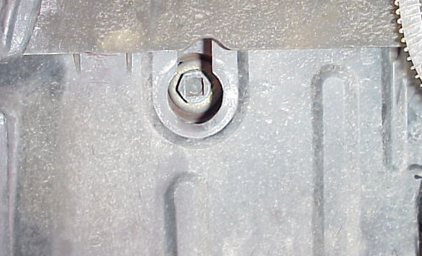

[Edit by J. Lucius: You will need to remove the intake plenum. Look at instructions on John Adam’s web page http://www.vr4stealth.com/plenum_removal_plugs_injectors.htm
or within my web page http://www.stealth316.com/2-msd-ignwires.htm . You will also have to remove the rocker covers.]

3. Now to start removing the lifters. The lobes need to be in the “up” position. In the first picture, I am pointing to the lobes on the camshaft. Notice how they are in the “down” position. You need to turn the crank (clockwise) until they are in “up” position as in the second picture. The reason for this, besides opening/closing the valves, is so you can pull the lifters out without them hitting the lobes. Also, this lets you access the valve springs.

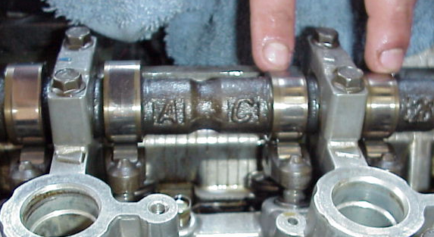

Here, the lobes are in the position (up) to remove the rockers and lifters.

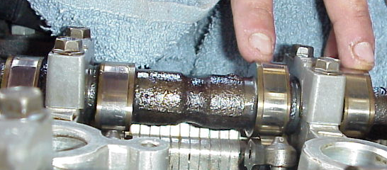

4. Now for the fun part. You need to get the rockers off the lifters and valve springs. The rockers are on the lifters and valve springs, which are held in place by the camshaft’s lobes. The springs need to be pressed down, which will cause the lifter side of the rocker to rise off of the lifter.

In the first picture, I was told to press on the valve spring to remove the rocker. Unless I was doing this wrong, it didn’t work for me because I couldn’t get enough pressure on the spring with one hand, and remove the rocker with the other. If there are two people, this would probably be the best way for removing the rockers. I decided to put duct tape on the ends of the screwdrivers so I would have less chance of scratching machined parts of the lobes and other parts.

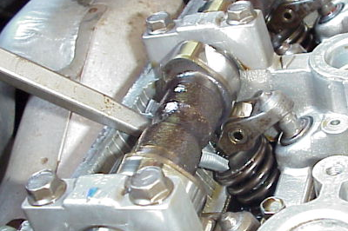

EDIT: After installation, I was informed that you are supposed to pry the valve spring down with the camshaft being the leverage point. Try each way to see which would be easier for you.
Since I couldn’t do it this way (picture above), I decided to remove the rockers by prying them up from the lifter side, causing the springs to depress (picture below). The only thing about doing it this way is you need to be sure not to scratch/scar any important parts.

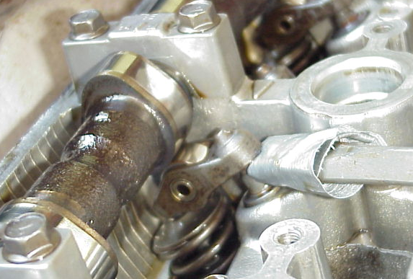

Now that the pressure is being applied to the valve spring, the lifter side of the rocker should raise off of the lifter. This may be enough for the rocker to “snap” free. If not, use another screwdriver to push the rocker off of the lifter. Note: Because of the pressure, the rockers may have a tendency to “fling” off. I had one that shot totally out of the engine compartment. To keep this from happening, place a magnet tool on the rocker while removing it. This will keep it from flying away from you.

Here is a picture of the rocker when it is off. Inspect the rockers for any unusual wear.

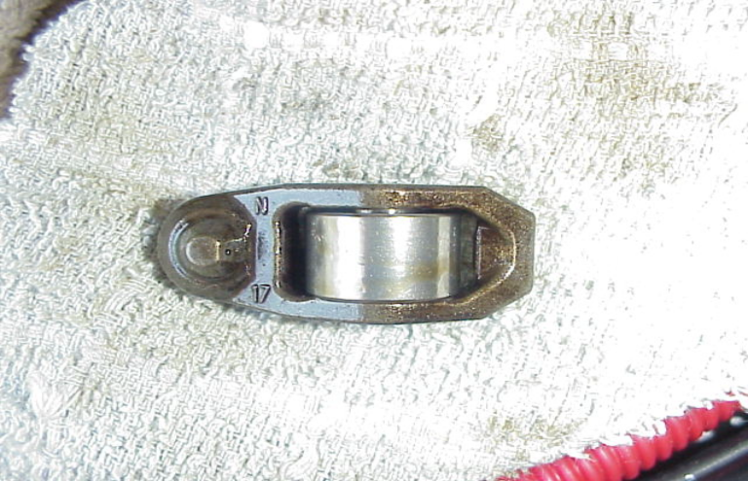 1

5. Remove the old lifter. Some of them will come out easy, and some of them might be a little harder to remove. As in the picture below, I removed it with a magnet tool. Others I had to use pliers to remove. Once it is removed, drop in a new lifter. Make sure that you have “primed” the lifter you are putting in by letting it soak in oil.

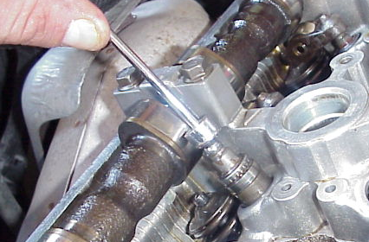

6. Now for the harder part of the process. Getting the rocker back on the valve spring and new lifter. You basically reverse the process from taking it off.

A: Place the rocker back on the valve spring, with the lifter part of the rocker next to the lifter. Keep it in place (will fall off if not supported) with a screwdriver.

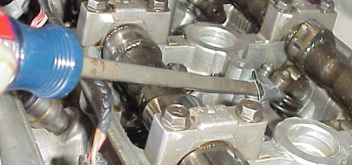

B: Now with the screwdriver in place, pry the rocker up and over the top of the lifter. Make sure not to damage any parts with the screwdriver. Use extra caution at the tip of the screwdriver. I slightly scratched one of my lifters trying to rotate the screwdriver in my hand. The best way I found to get the rocker back on top of the lifter was to use another screwdriver to help guide it back on (pictured below).
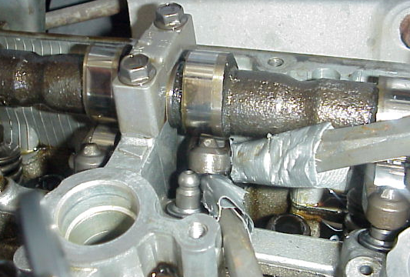

C: Now, the rocker should be back in place. On about ½ of mine, the rocker was on top of the lifter, but it didn’t “snap” into place. It was just wedged on top. You can either tap the valve spring side of the rocker to nudge it into place, or what I did was use an 8mm offset wrench (pictured below) to nudge the rocker onto the lifter.

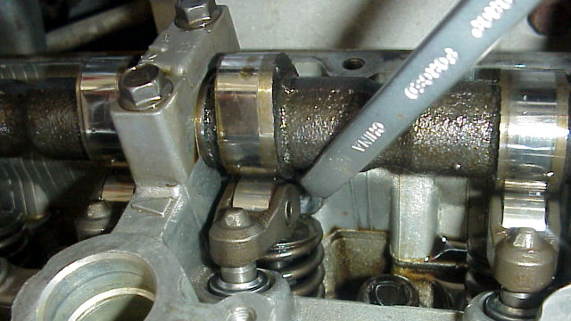

Now, the new lifter should be installed. From the current crank position, the lobe beside the one you just replaced will be in the up position also. Replace that lifter. There will also be two other lobes on the opposite head/bank that is in the “up” position. Go ahead and replace those lifters, then turn the crank clockwise until another lobe is in the “up” position. Then repeat the above process.

From these instructions, it might seem that this is a two day job. It isn’t. Once you do the first couple lifters, you’ll get the hang of it. On the first lifter, I thought I got in “over my head”. But once I figured it out, it got a lot easier. If you are not very mechanically inclined like myself, set aside a whole day just in case you run into problems. Not counting breaks, it took me about 4 hours to do the actual replacement, not counting prep time for taking off the intake and valve covers.

Good luck!!!

Brad Wright
unit979 (3SI)

Thanks to 3SI’s moparjim and xwire for their advice on doing this!!!

